Exercise 7
Create the following time table in HTML with Dummy Data.
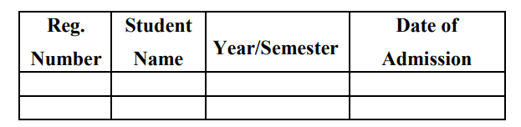
Solution:-
<html>
<head>
<title>Exercise 7</title>
</head>
<body bgcolor= #FFC0CB>
<h1 align="center" ><font color="Salmon">Timetable of BCA</font></h1><br>
<table align="center" border="2" cellspacing="0" cellpadding="15" bgcolor= #00FFFF>
<tr align="center" valign=="middle">
<th>DAY</th>
<th>I</th>
<th>II</th>
<th
rowspan="7"><b>T<br>E<br>A<br><br>B<br>R<br>E<br>A<br>K</b></th>
<th>III</th>
<th>IV</th>
<th
rowspan="7"><b>L<br>U<br>N<br>C<br>H<br><br>B<br>R<br>E<br>A<br>K</
b></th>
<th>V</th>
<th>VI</th>
<th>VII</th>
</tr>
<tr align="center">
<th>MON</th>
<td>IS</td>
<td>WT</td>
<td>SEM</td>
<td>OOAD</td>
<td>SCI</td>
<td>C#</td>
<td>COMP</td>
</tr>
<tr align="center">
<th>TUE</th>
<td>AP</td>
<td>AP Lab</td>
<td colspan="2">AP Lab</td>
<td>WT</td>
<td>IS</td>
<td>OOAD</td>
</tr>
<tr align="center">
<th>WED</th>
<td>WT</td>
<td>IS</td>
<td>C#</td>
<td>SCI</td>
<td colspan="3">MOOC'S</td>
</tr>
<tr align="center">
<th>THU</th>
<td>IS</td>
<td>LIB</td>
<td>OOAD</td>
<td>WT</td>
<td colspan="3">WT Lab</td>
</tr>
<tr align="center">
<th>FRI</th>
<td>AP</td>
<td>AP</td>
<td>C#</td>
<td>OOAD</td>
<td colspan="3">C# Lab</td>
</tr>
<tr align="center">
<th>SAT</th>
<td>OOAD</td>
<td>SCI</td>
<td>WT</td>
<td>SEM</td>
<td>AP</td>
<td>AP</td>
<td>C#</td>
</tr>
</table>

</body>
</html>

Output:-
